Final Report

Project Title: Classification for Conservation

Class: CSCI 487 Section 1 SPRG 2024

Student Name: Robert Hooker | Email: [rhooker@go.olemiss.edu](mailto:rhooker@go.olemiss.edu)

Sponsor Name: Hong Xiao | Email: [hxiao1@olemiss.edu](mailto:hxiao1@olemiss.edu)

**Abstract**

This project, classification for conservation, is a convolutional neural network to detect and classify wildlife data. Machine learning (ML) has been used to automate and improve processes around the world. This project is a demonstration of how it can help ecologists monitor habitats. Statistical learning is a topic that I have become interested in and wanted to learn further about by getting hands on experience. I am also a nature lover, and want to contribute to the conservation of wildlife, so this was an opportunity to apply my computer science knowledge to a cause that I am passionate about. To complete this project, I gathered data and trained the model using the state-of-the-art CNN framework YOLOv8. To carry this out I needed to assemble the data such that I could use YOLOv8 with cloud computing, which allowed for reasonable training times. To validate the model, a section of the data was used as test data to measure how the model is performing by various statistics. The minimum viable product of the project was to build an ML model which accurately detects and classifies wildlife in image data, which has been achieved.

**Report**

In carrying out the project, it was evident that I would have to be constantly adjusting the design and requirements of the project in order to achieve the desired product. As I learned more about the paradigms and problems related to building such a model, I better understood the project and where it needed to be improved. In this process I realized what I did well, and what could have been done better from the start. This taught me important lessons on ideation to product which I will value in future development and endeavors.

In designing the project, I think I did well to choose a topic that has been broadly researched and that has a massive community. From the beginning there was going to be a big learning curve as I had never worked in ML prior, but this was attainable because of the vast number of related resources. I also consider myself very lucky to have had Dr. Xiao as my sponsor for this project. Dr. Xiao is very versed in ML and was always willing to support me in my efforts. This includes guiding me in my process, explaining technologies or theories, and discussing ideas and possibilities with me.

I also ran into issues with my original design for the project implementation, the two main ones being my choices of dataset and cloud compute engine. Originally, the dataset I was using had non-uniform sized, infrared images, and annotations in csv format. The non uniform images with csv annotations ended up being a large set back as this is not an agreeable format for YOLOv8. After spending time writing a script to convert the CSVs to the correct format, I was faced with resizing the images and annotations accordingly. The programs I was writing to do never worked properly for all the images, so I had to make the decision to seek out a more suitable dataset in order to complete the project on time. This was a dejecting process as I thought the original dataset would have been interesting to work with, and it ended up costing me around two weeks of work. When I was configuring the setup to train the model, I was initially doing so in Google Cloud Platform (GCP) as I decided it would be the best place to house and train on big data. While its access to GPU’s was great and it offered enough storage for my project, what I failed to realize was how expensive it is. Once I concluded that it would cost about $400 to use GCP I decided to change computing environments. This was another setback as I had to reconfigure the project to google Collaboratory and google drive.

My main motivation for this project was to get hands on experience with ML and learn techniques of the field. When I consider this goal, I think I was able to achieve it from a high level but wish I had gotten more low-level exposure. I think this results is a product of the large endeavor that the MVP was. To train an object detection model with multiple classes requires a large, robust dataset and a highly complex algorithm. It is for these reasons, which I gathered from reading research papers and speaking with Dr. Xiao, that I realized I would have to use an existing data set and implement a state-of-the-art algorithm. So, I think I would have been better off choosing a simpler task in the ML space. That way, I could have built my own dataset and design my own custom algorithm, which would have resulted in a better low-level understanding of the field. This is not to say I did not find value in the project however, as using and understanding state-of-the-art tools presents its own challenges and insights.

Those insights include neural network architecture, training parameters, convolutions, loss functions, and various statistical methods important in ML. I consider these the technical aspects of my learning during this project, and believe they’ll be useful in my further work in data science and ML. On the other hand, I learned valuable non-technical lessons in project development/management. One that sticks out is how important it is to have someone to be able to talk to about your project. Being able to talk through issues and ideas with Dr. Xiao increased my productivity greatly. On top of this, sharing my progress with the class both held me accountable and forced me to be constantly reviewing the product. Finally, I reinforced a notion I already had, which is that in computer science there are many ways to achieve the same goal, but decisions still have an impact on the level of the final product. I think this mindset will help me be deliberate in planning and implementing future endeavors.

Going forward, I will continue to carry out personal projects such as this one, and I trust that the insights I have gained here will show in my future work. Additionally, I hope to one day find work using ML to make an impact on our planet, and I’ll look back on this project as the beginning of that journey.

**Design Specifications**

User Requirements

For this project, the Minimum Viable Product (MVP) is a machine learning model that accurately detects and classifies wildlife in aerial images. In addition to the MVP, we’ve implemented bounding box tracking on wildlife videos, using our trained model. Beyond these features, we now look to code a custom detection model from scratch, which would provide us insight into how the model architectures we have used work internally, specifically why they are effective. The users of this model are conservation/ecology practitioners and other machine learning (ML) enthusiasts curious about computer vision in wildlife. For ecologists, the model could be leveraged to assist them in the field. For instance, it could be used in accordance with drones that feed the model live wildlife imagery, allowing for real time detection and tracking of animals in their natural habitat. Another practitioner may use a variation of this model to take species censuses with unmanned aerial vehicle (UAV) scans. For other ML enthusiasts, the public code for this product could serve as a starting point or reference if they are looking to explore similar ideas as this project. They’ll be able to take the code and modify it to answer questions they might have relating to the topic.

Design Choices

1. Datasets

The datasets that were considered for the model were publicly available datasets built for the purpose of wildlife object detection, luckily there are many such datasets. The alternative to these would be to create a custom dataset for this project, however the cost and labor to do so would be far out of the scope of this course. The main variations in the available datasets are the number of classes (animals) in the data, number of images, image size, image type (i.e. infrared), and bounding box annotation format.

The ideal dataset for this project would have multiple different classes, a substantial number of images (~2500+), uniform image sizes, RGB images, and bounding boxes with normalized coordinates. Multiple classes was important for us as this would make the model more versatile and robust. Generally, in training ML models, there is a positive correlation between the amount of data and the accuracy of the model, hence it was important to find a large dataset. Uniform image sizes are useful because it eliminates the need to scale each image to a uniform size, the same is true for bounding box coordinates. RGB images are ideal for this model because they would make the model more widely applicable, as most wildlife images are in RGB.

Considering these parameters, the selection pool was narrowed down to two datasets. These being Conservation Drones1 and WAID: A Large-Scale Dataset for Wildlife Detection with Drones2. Conservation Drones consisted of 9 classes and 162,000 total images. The large number of classes and images are what made this set a good candidate for our model. The images, however, are infrared and non-uniform in size, with corresponding bounding box coordinates which are not normalized. The WAID dataset on the other hand contains 6 classes and 14,366 images. These images are at a uniform 640x640 and in RBG, with normalized bounding box coordinates.

1. Technology Stacks

The decisions made to train this model include choosing between programming languages, machine learning frameworks, runtime environments, and model architectures. For developing a machine learning model, we would like to use a language that is well equipped to handle statical methods. Currently, Python and R are the most popular languages for statistical development, as they are both very capable of data analysis and visualization. R also has support from a number of machine learning packages and is used in the industry. Similarly, Python has vast support for data analysis, visualization, and machine learning, so the programming language decision comes down to preference and specific requirements, such as the chosen model architecture.

Next, the machine learning frameworks available includes TensorFlow, Pytorch, and Scikit-learn. TensorFlow is generally known to be ideal for the production of models and is praised for its stability and scalability, so it is a framework commonly used in the industry. It has a relatively high learning curve compared to Pytorch and Scikit-learn, but this gap is decreasing with recent updates to TensorFlow. Scikit-learn is one of the original machine learning libraries and is still widely used by practitioners and researchers alike. It does not however match the number of tools provided by the other two frameworks at hand, which can make model development more tedious. Finally, Pytorch was developed specifically for Python, as the name would suggest. The framework is intuitive for Python users, as its syntax is Pythonic, and it is compatible with other popular Python libraries like NumPy, Pandas, and Matplotlib.

Next, the decision of runtime environment for the model comes down to a decision between cloud hosted runtime services. This is because to train the model in reasonable time, we used access to a cloud GPU, which greatly speeds up runtime. The options considered for this were Google Cloud Platform’s Vertex AI, Google Collaboratory, and Amazon Web Services (AWS). Vertex AI and AWS are the state-of-the-art services for accessing cloud compute power, training, and deploying models. These products are typically used in industry and are tailored for businesses who are looking to store data and access compute via the cloud. For this reason, these options can get rather pricey, and although they each use a pay as you go model, it can get steep fast. Google Collaboratory is a hosted jupyter notebook service, that is more tailored to the individual user rather than industry. It provides access to cloud GPUs for free, and for $10/month users can access more powerful GPUs.

Finally, the model architecture chosen to train the model is essential in manufacturing capability. There are a number of machine learning and deep learning algorithms and architectures, but it is widely agreed upon that for object detection in images, convolutional neural networks (CNN) are optimal. This, however, leaves us with the decision of which CNN architecture is most suitable for our task. Architectures suited for object detection include Faster R-CNN, YOLO (multiple versions), and SSD, among many others. Faster R-CNN is a two-stage detector, meaning one stage of its algorithm is dedicated to region proposal, and the other dedicated to classification and bounding box output. These stages work together, as the region proposal stage acts as an attention mechanism for the classification stage3. SSD and YOLO on the other hand, are ‘single shot’ object detectors, meaning they have one stage that produces classes and bounding boxes for a given image, without the assistance of an attention mechanism. This design allows the networks to perform faster than networks with multiple stage detection, however there are tradeoffs. Multiple stage detectors like Faster-RCNN tend to be more accurate, especially when detecting relatively small objects. In recent years, however, YOLO and SSD have been improved, closing this accuracy gap while retaining their speed.

Design Selected

The dataset selected for our model was the WAID dataset. It contains 14,366 images of wildlife, split into train, validation, and test sets at a 7:2:1 ratio, respectively. For each image in the set there is an accompanying .txt file which contains the class of each animal in the image, along with their bounding box coordinates. This data format is known as “YOLO” format, as it is used for the ever-popular real-time object detection algorithm, YOLO (You Only Look Once). The images in this set are also a uniform 640 x 640 pixels, which is the default input for YOLOv8, which was the state-of-the-art version during the training of this model. Several other datasets were considered; however, it was determined that WAID was the most comprehensive and usable set of those available. The animals included in the data are cattle, sheep, kiang, camels, seals, and zebras.

Next, the programming language of choice is Python, along with the Pytorch machine learning framework. This combination is an obvious choice for someone familiar with Python like me, as it presents a small learning curve. The tradeoffs from R to Python are not relevant to this project, and using R would only present me with another programming language to learn. Similarly, TensorFlow and Scikit-learn would have worked for developing this model, but Pytorch is more aligned with the rest of the tech stack and my existing knowledge.

The runtime environment chosen ended up being Google Collaboratory. Vertex AI and AWS are more than capable platforms for this project; however, they would be overkill. If I were to use these, I would be paying for a plethora of features that I didn’t need, amounting to roughly $400, whereas Google Collaboratory costs $10/month and provides all the resources necessary for this project. Additionally, Google Collaboratory is a hosted jupyter notebook service, which is an environment meant to run Python, our language of choice.

Finally, the detection algorithm chosen was YOLO, specifically YOLOv8, the most recent model at the of training. YOLOv8 is well suited for this detection model, as it is both fast and accurate. With the addition of multiple scale detection, YOLO has significantly decreased the accuracy gap between it and Faster R-CNN, making it a great option for real time object detection. Additionally, the dataset we have chosen is already in YOLOv8’s default format, so this architecture will work seamlessly with our dataset, WAID. YOLOv8 also has extensive documentation4 and a large user base, so there are an abundance of resources regarding the use of it. The docs were used as reference for completing the model training, testing, and tracking code, which can be found in my GitHub Repository5 for the project.

The diagram below shows the internal architecture of YOLOv8, in all its complexity. This will be beneficial in explaining the structure of the system and this project. So, from our dataset we give the model a 640x640 image. The convolution layers of the algorithm downsize the image while performing various convolution operations, each of which produces a feature map. In theory and practice, these feature maps contain key information edges, corners, patterns, gradients, etc. These convolution layers along with activation and pooling layers eventually shrink the input image to an output tensor. This tensor contains the algorithm’s prediction for the classes of the objects detected, along with their corresponding bounding boxes.

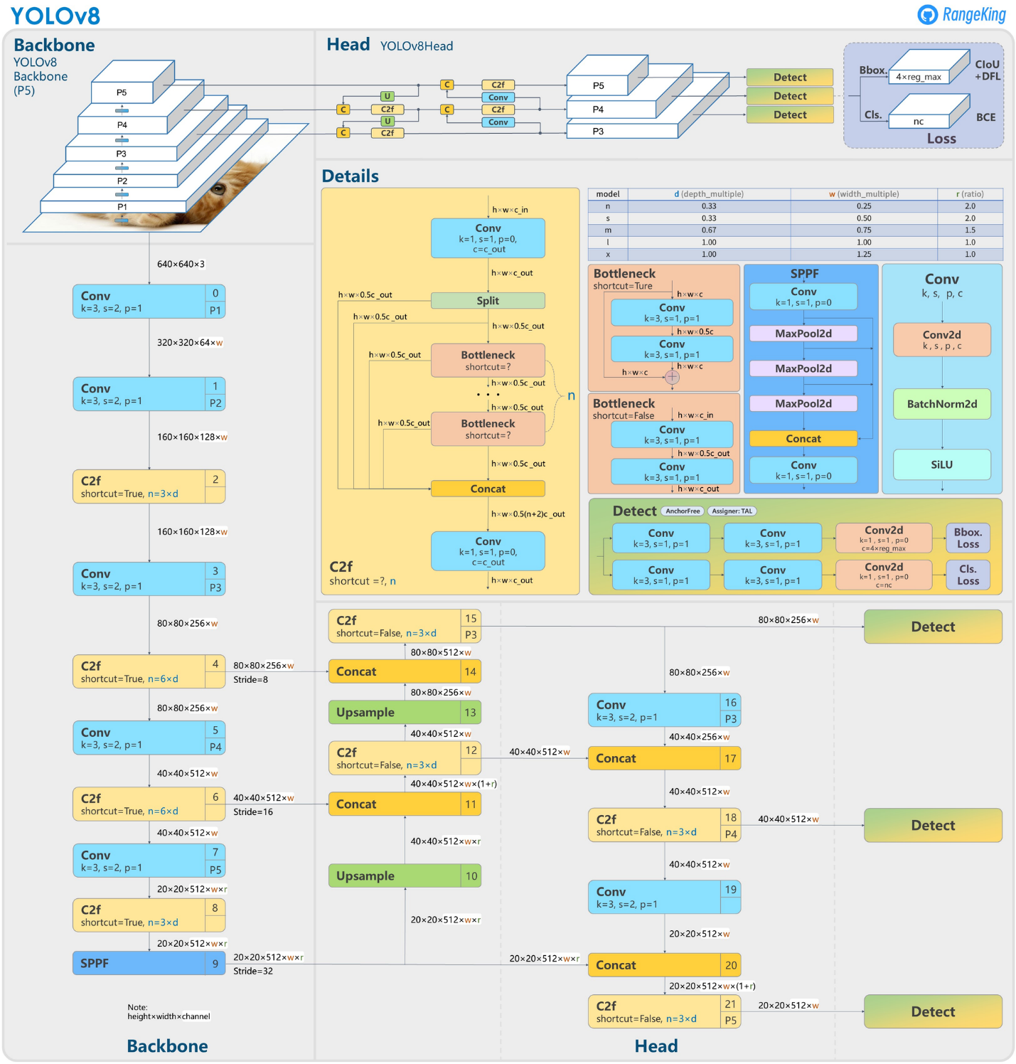

Figure from article: *What is YOLOv8? The Ultimate Guide.*6

Originally, these predictions are random, as the model has no sense of the truth, however over each training iteration (epoch), a proper machine learning model will decrease its error and become a sufficient predictor. It does so by comparing its output prediction to the ground truth classes and bounding boxes that correspond with the image in our dataset. The algorithm calculates the error between its prediction and the truth and uses it to adjust the parameters that determine the convolution function, this is known as back propagation. As the parameters become better and better at predicting the contents of the images, the model becomes learned.

After all this training we can extract the final weights of the neural network and use them to make accurate predictions on images never before seen by the model.

User Interaction

 The code snippet below is an example of how the model is used to track objects in consecutive images. The function ‘model.track’, using our trained weights ‘animalDetector.pt’, can also be configured to input a live camera feed. So, a field ecologist might use this in accordance with drones that feed it live wildlife imagery. Coupling this with a dedicated GPU would allow for real time detection of animals in their natural environment.

Although the tracking outputs frames with the animal’s class and bounding box overlayed onto the image, it is also possible to extract this data to JSON or CSV format. Doing so would allow ecologists to measure different aspects of the environment over long time periods.

Development/Deployment Environment

As mentioned in the design selected section of this document, the chosen development environment for this project was Google Collaboratory. This was necessary as it allowed me access to cheap cloud GPU’s that cut the training time of the model substantially. Also, I was able to store the entire WAID dataset in my google drive, which has seamless interaction with Google Collaboratory. Finally, once the code was running properly, I uploaded it to my GitHub repository5 to maintain versions of the project as it progressed.

The model can also be used to make predictions in Google Collaboratory, still utilizing the GPU’s. This allows us to make real time predictions using cloud computing, in the same environment of development.

Test Plan

Testing the model will be carried out by statistical tests on the designated test data and tracking tests on out of sample wildlife videos. The designated test data contains 1,437 images which the model was never exposed to. Upon predicting classes and bounding boxes for these images, we’ll verify that the accuracy and error statistics of the model hold when its applied to new data. Furthermore, using the model on out of sample wildlife videos will give a tangible demonstration of the model working. If this tracking works, it will also signify that the model is not overfit to imagery that is part of the WAID dataset.

**Slideshow Presentation**

